**Unit 9: Analyzing Qualitative Data**

Welcome to week 9 where you will be looking at the different methods available to you for analyzing qualitative data.

By its very nature, qualitative data is open to different interpretations. So, it is harder for the researcher to remain unbiased. If this is the type of data you will obtain from your research, you will need to keep this in mind when presenting your results.

Qualitative data analysis works a little differently from quantitative data, primarily as qualitative data is made up of observations, images, and words. It is almost impossible to derive absolute meaning from such data. Hence, the reason it is used mostly for exploratory research. Another key difference between quantitative and qualitative data is in the analysis: analysis for qualitative research often begins as soon as the data is available whereas there is a clear distinction between data preparation and data analysis stages in quantitative research.

In order to analyse qualitative data, such as responses from an unstructured qualitative interview, there is a need to code the responses. Coding here refers to the categorisation of data. BRM (2021) goes through types of qualitative data coding. Software is often used to ensure efficient coding and analysis, and sometimes involves cleaning the data.

**In this unit we shall:**

* Introduce the various ways to analyse, interpret and present results from qualitative data.
* Discuss the advantages and drawbacks of each of these methods.

**On completion of this unit you will be able to:**

* Understand the different types of analysis and how they may be useful for the data you have collected.
* Understand the different charts available to present the different types of data you have obtained.

Data, whether qualitative or quantitative, will be a key part of any investigation you undertake. An important consideration is then how to present your findings in a way that communicates your message to the reader. Charts and graphs are a good way to present data, both qualitative and quantitative and are usually used to set the scene.

**Reflection:**

Data analysis plays a crucial role in the smooth operation of any firm. If properly analyzed, data can shed light on a company's past successes and guide strategic planning for its future endeavors. Information can be used in a wide variety of contexts across an organization.

In all fields, four distinct approaches to data analysis are utilized.

**[Types of Data Analysis](https://chartio.com/learn/data-analytics/types-of-data-analysis/" \l "four-types-of-data-analysis)**

The four types of data analysis are:

* Descriptive Analysis
* Diagnostic Analysis
* Predictive Analysis
* Prescriptive Analysis

Below, we will introduce each type and give examples of how they are utilized in business.

1. **[Descriptive Analysis](https://chartio.com/learn/data-analytics/types-of-data-analysis/" \l "descriptive-analysis)**

Descriptive analysis is the initial sort of data analysis. It's the backbone of any data analysis. This is the most basic and widespread application of data in modern commercial settings. What-Happened questions are resolved by descriptive analysis, which often involves dashboard-style summaries of historical data (Chartio, n.d.).

### **[Diagnostic Analysis](https://chartio.com/learn/data-analytics/types-of-data-analysis/" \l "diagnostic-analysis)**

When the initial inquiry of "what happened" has been answered, the next step is to inquire as to "why did it happen?" The role of diagnostic analysis becomes clear here.

The purpose of diagnostic analysis is to investigate the root causes of the issues revealed by descriptive analytics. This type of analytics is used by businesses because it helps them find new patterns in their data.

### **[Predictive Analysis](https://chartio.com/learn/data-analytics/types-of-data-analysis/" \l "predictive-analysis)**

The goal of any predictive study is to provide a plausible explanation for the future. Analytics of this sort looks to the past for clues about the future.

These analyses are more advanced than descriptive and diagnostic ones. Our summarized data will be use in a predictive analysis that will allow us to make educated guesses about potential outcomes. More resources in terms of hardware and people are needed foreseeing the results of this analysis because it is based on statistical modelling. Keep in mind that forecasts are merely estimates, and that good information is essential for making reliable forecasts (Neo, 2020).

### **[Prescriptive Analysis](https://chartio.com/learn/data-analytics/types-of-data-analysis/" \l "prescriptive-analysis)**

Despite its popularity, relatively few businesses have the resources to conduct the third and final type of data analysis. To solve a current problem or make a current choice, prescriptive analysis, the cutting edge of data analysis, synthesizes the knowledge gained from all prior analyses into a single, actionable set of recommendations.

The data and methods used in prescriptive analysis are cutting edge. Because of the magnitude of the commitment required, businesses should carefully consider whether they are prepared to make it.

An excellent illustration of prescriptive analytics is artificial intelligence (AI). Artificial intelligence systems require a massive amount of data to train themselves effectively and then apply this knowledge to new situations (Stevens, 2020).

**Charts for Data Visualization:**

When working with data, charts are crucial because of how they simplify complex information. Data visualizations can provide insights to a new viewer of the data and communicate discoveries to viewers who will never see the raw data. Countless varieties of charts exist, each with its own niche applications. The process of determining the appropriate chart type for a given data visualization is often the most challenging aspect of making the visualization itself.

Several things will influence the sort of chart you ultimately decide to use. To what extent do you plan to plot metrics, characteristics, or other variables? Do you want to present to a small group of people as a means of preliminary research, or do you intend to share the findings with a wider audience? In what way do you want the reader to interpret your work? (Chartio, n.d.)

1. **BAR CHART**

In a bar chart, the length of the bars represents a value, and each group of bars represents a discrete set of data points. Vertical bar charts, often known as column charts, are a special case of the more common horizontal bar chart. When there are many bars to plot or when the labels need more area to be readable, a horizontal bar chart is an excellent choice.

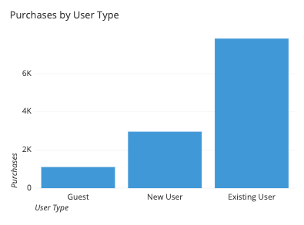

1. **LINE CHARTS**

Line graphs illustrate how values change over the course of time or other continuous measures. The line's upward or downward movement aids in highlighting positive and negative shifts, respectively. It may also reveal broad tendencies that can be used to foretell or forecast future events. Similar charts, such as the sparkline and the ridgeline plot, can develop from many line plots.

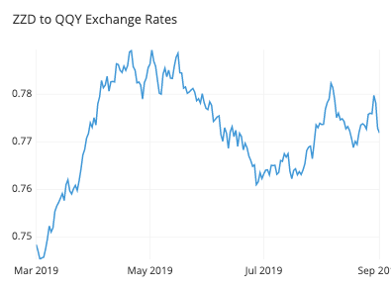

1. **SCATTER PLOT**

An example of a scatter plot is a graph in which points represent numerical values for two different variables, with the values for each variable represented by a separate axis. Scatter plots are a flexible tool for depicting the strength, direction, and shape of any correlation between the variables shown. Furthermore, scatter plots are useful for discovering data gaps and unusual observations.

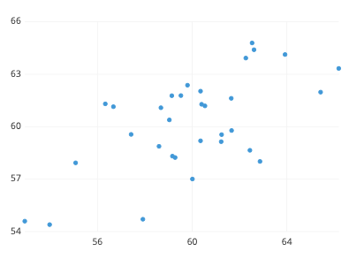

1. **BOX PLOT:**

To visually represent the range of values found within a set of measurements, statisticians often resort to the usage of box plots with their accompanying whiskers. Most of the data falls inside the regions indicated by the box and whisker endpoints. Whenever there are

more than two groups to compare, a box plot is used, whereas other, more detailed charts are used when there is only one (c) Copyright skillsyouneed.com 2011-2019, 2011).

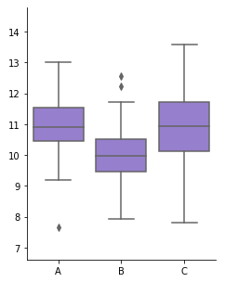

**References**

Business Research Methodology (BRM) (2021) Qualitative Data Analysis.

Chartio. (n.d.). *Types of Data Analysis*. [online] Available at: <https://chartio.com/learn/data-analytics/types-of-data-analysis/#descriptive-analysis>.

Neo, B. (2020). The Six Types of Data Analysis. *Medium*. [online] 27 Oct. Available at: <https://towardsdatascience.com/the-six-types-of-data-analysis-75517ba7ea61>.

Stevens, E. (2020). *What Are the Different Types of Data Analysis?* [online] careerfoundry.com. Available at: <https://careerfoundry.com/en/blog/data-analytics/different-types-of-data-analysis/>.

Chartio. (n.d.). *Essential Chart Types for Data Visualization*. [online] Available at: <https://chartio.com/learn/charts/essential-chart-types-for-data-visualization/#bar-chart>.

c) Copyright skillsyouneed.com 2011-2019 (2011). *Graphs and Charts | SkillsYouNeed*. [online] Skillsyouneed.com. Available at: https://www.skillsyouneed.com/num/graphs-charts.html.